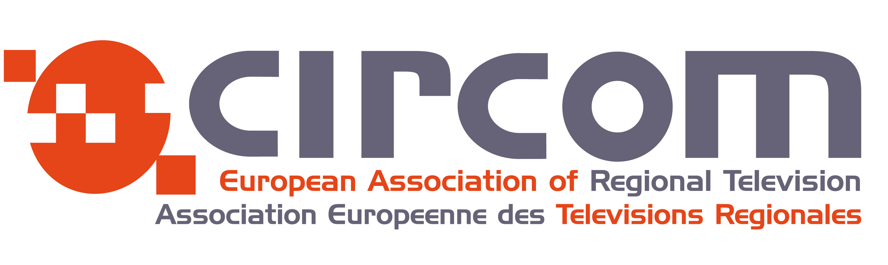

REGISTRATION FORM
34th Annual Conference of CIRCOM Regional
19 – 20 May 2016, Plovdiv, Bulgaria

Mr. Mrs.:

First Name:

Last Name:

Job Title:

Company/Organization:

Company Address:

Country: City: Zip (Postal Code):

Work Telephone: Mobile Phone:

Email:

I will attend:

Executive Committee  yes
European Board and Annual Assembly  yes
Annual Conference  yes
Workshop in Sofia  yes

I will be accompanied by …..
Full name ……

Travel Information
Arrival
Date: Time:

Departure
Date: Time:

Social event

I will attend guided City Tour in The Old Town of Plovdiv on 21.05.2016:  yes no

Besides in English, tours in the following languages could also be organized in case there are enough attendants. Please indicate your preference!

English  yes no Russian  yes no

French  yes no German  yes no

* Please send this form till 27 April 2016 to the following email address bnt.circom@bnt.bg

