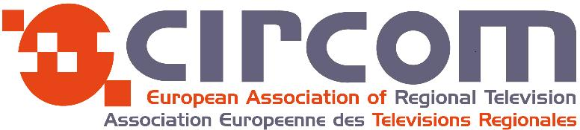

Application Form - RAI CRITS Webinar
“Application of Artificial Intelligence in Media Industry”

Wednesday 21st of October 2020
10:00 am (CEST) /09:00 am (GMT)
Via Teams

It requires a good command of spoken English.

PERSONAL DETAILS: Mr Mrs

First name:

Surname:

Job Title:

Job description:

Your Mobile Phone Number:

Your email address:
(We will send you an invitation to allow you to connect via Teams to the webinar)

Company Name:

Name of your CIRCOM Regional National Co-ordinator:

DEADLINE: Tuesday 20th of October 2020

PLEASE RETURN THE APPLICATION FORM BY EMAIL TO:
Email: lucie.durand@circom-regional.eu and lucie.durand@francetv.fr

